**SUMMER INTERNSHIP PROJECT REPORT 2**

**KINEMATIC ANALYSIS OF THE GEARED FIVE BAR LINKAGE**

**DRDO, GTRE**

**GAS TURBINE RESEARCH ESTABLISHMENT**

RSIF, Gearbox Division

*Joe Joseph*

*BTech 5th Semester, Mechanical Engineering*

*Delhi Technological University*

**Problem Definition**

**Problem (4-16) (pg-206):** The link lengths (mm), gear ratio, phase angle and value of θ2 (deg) for some geared five bar linkages are defined in the Table given. The linkage configuration and terminology are also given. For the rows (cases) assigned, draw the linkages to scale and graphically find all possible solutions for the angles θ3 and θ4.

**Problem (4-17) (pg0-206):** Repeat the problem, except solve by the Vector loop method.

**Problem (6-10) (pg-311):** The linkage configuration and terminology are given. The link lengths (mm), gear ratio, phase angle and value of θ2 (deg) and ω2 (rad/s) are defined. For the rows (cases) assigned, draw the linkages to scale and graphically find all possible solutions for the angular velocities ω 3 and ω 4.

**Problem (6-11) (pg0-312):** Repeat the problem, except solve using analytical method.

**Problem (7-9) (pg-358):** The linkage configuration and terminology are given. The link lengths (mm), gear ratio, phase angle and value of θ2 (deg), ω2 (rad/s) and α2 (rad/s2) are defined. For the rows (cases) assigned, draw the linkages to scale and graphically find all possible solutions for the angular velocities α 3 and α 4.

**Table**

|  |  |  |  |  |  |  |  |  |  |
| --- | --- | --- | --- | --- | --- | --- | --- | --- | --- |
| **link a** | **link b** | **link c** | **link d** | **link f** | **Gear ratio** | **Phase** | **θ2** | **ω2** | **α2** |
| 25.4 | 177.8 | 228.6 | 101.6 | 152.4 | 2 | 30 | 60 | 10 | 0 |
| 127 | 177.8 | 203.2 | 101.6 | 152.4 | -2.5 | 60 | 30 | -12 | 5 |
| 127 | 177.8 | 203.2 | 101.6 | 76.2 | -0.5 | 0 | 45 | -15 | -10 |
| 127 | 177.8 | 203.2 | 101.6 | 101.6 | -1 | 120 | 75 | 24 | -4 |
| 228.6 | 279.4 | 203.2 | 203.2 | 127 | 3.2 | -50 | -39 | -50 | 10 |
| 50.8 | 177.8 | 127 | 76.2 | 254 | 1.5 | 30 | 120 | -45 | 50 |
| 177.8 | 228.6 | 279.4 | 101.6 | 381 | 2.5 | -90 | 75 | 100 | 18 |
| 203.2 | 177.8 | 228.6 | 101.6 | 304.8 | -2.5 | 60 | 55 | -65 | 25 |
| 177.8 | 203.2 | 228.6 | 101.6 | 228.6 | -4 | 120 | 100 | 25 | -25 |

**Diagram**

**O2**

**C**

**B**

**A**

**Y**

**X**

f

d

c

b

a

r1

r2

θ5 ω5 α5

θ2 ω2 α2

θ4 ω4 α4

θ3 ω3 α3

**O5**

**Solution**

MATLAB was use to generate the code and find the solution to the above problem.

|  |  |  |  |  |  |  |  |  |
| --- | --- | --- | --- | --- | --- | --- | --- | --- |
| **OPEN** | | | | | | | | |
| **θ3** | **ω3** | **α3** | **θ4** | **ω4** | **α4** | **θ5** | **ω5** | **α3** |
| 173.6420808 | 32.58479813 | 3191.23368 | -177.7151939 | 16.94777004 | 2492.42117 | 150 | 20 | 0 |
| 39.61603327 | 30.67980149 | 548.7550473 | 91.01155514 | 17.25229813 | 592.3686348 | -15 | 30 | -12.5 |
| 17.64949167 | 10.73070073 | 313.7332982 | 63.97170476 | -2.612209709 | 271.5111024 | -22.5 | 7.5 | 5 |
| 56.33390745 | -26.95416576 | 959.3800171 | 101.9309955 | 3.418731192 | 962.1203771 | 45 | -24 | 4 |
| -163.9684979 | -158.3477533 | 2171.49476 | -94.37894611 | -81.26435816 | 5803.002881 | -174.8 | -160 | 32 |
| 12.50544298 | 25.84357843 | 247.5393965 | 108.2762658 | -29.49179792 | 3392.166494 | 210 | -67.5 | 75 |
| 44.23475525 | -8.897384578 | -22064.14664 | 124.4198032 | -40.90302194 | -8453.52419 | 97.5 | 250 | 45 |
| -13.02086291 | 61.68259581 | 18217.75757 | 99.31739197 | 12.53777129 | -630.7553269 | -77.5 | 162.5 | -62.5 |
| 37.08166674 | -40.12041674 | -5697.461059 | 120.2054158 | 47.92190341 | -1868.806486 | -280 | -100 | 100 |

|  |  |  |  |  |  |
| --- | --- | --- | --- | --- | --- |
| **CROSSED** | | | | | |
| **θ3** | **ω3** | **α3** | **θ4** | **ω4** | **α4** |
| -115.4073608 | -75.19089915 | -6648.463007 | -124.050086 | -59.55387106 | -18315.04901 |
| -104.7632031 | 12.58117374 | 475.9262838 | -156.1587249 | 26.0086771 | -936.5449376 |
| -133.7434186 | -8.22593314 | 87.14901347 | 179.9343683 | 5.116977303 | 65.53225384 |
| -96.09366111 | 16.57338276 | 37.06053216 | -141.6907492 | -13.79951419 | -403.023198 |
| 111.224381 | -116.8064184 | 7781.003703 | 41.63482915 | -193.8898136 | -46008.28019 |
| -54.58690042 | -13.10391526 | 3271.284682 | -150.3577233 | 42.23146109 | -1424.043549 |
| -69.12850238 | -48.51219714 | -5529.279399 | -149.3135503 | -16.50655979 | -19443.99573 |
| -90.26046811 | 3.69724867 | -4373.410426 | 157.401277 | 52.84207319 | 12703.13045 |
| -67.38585336 | 59.63703088 | -2593.235453 | -150.5096025 | -28.40528926 | -7288.337257 |

**Images (curves)**

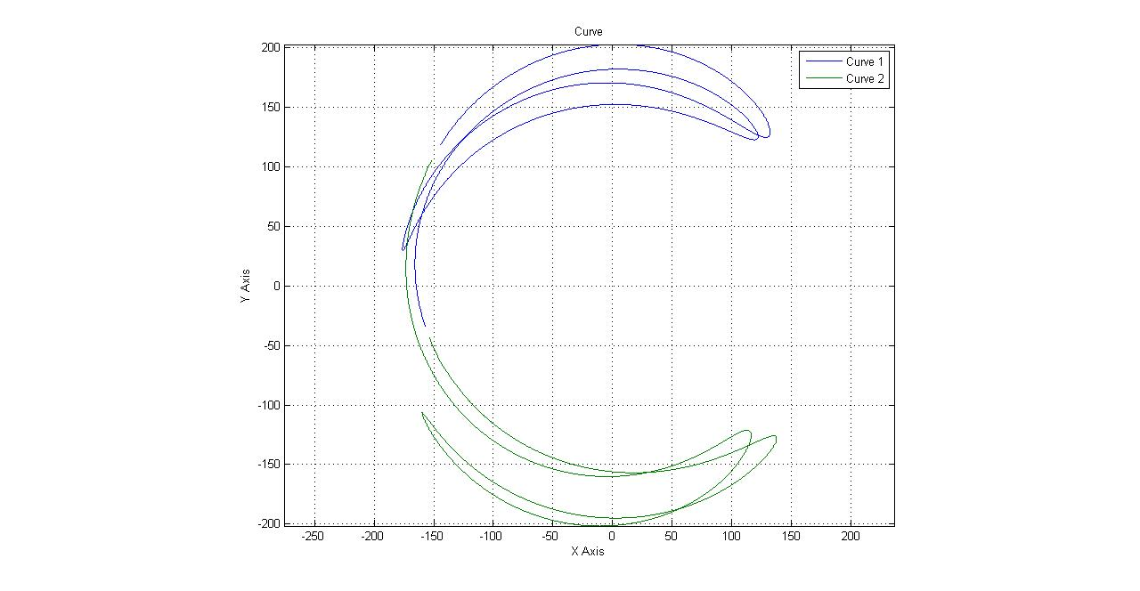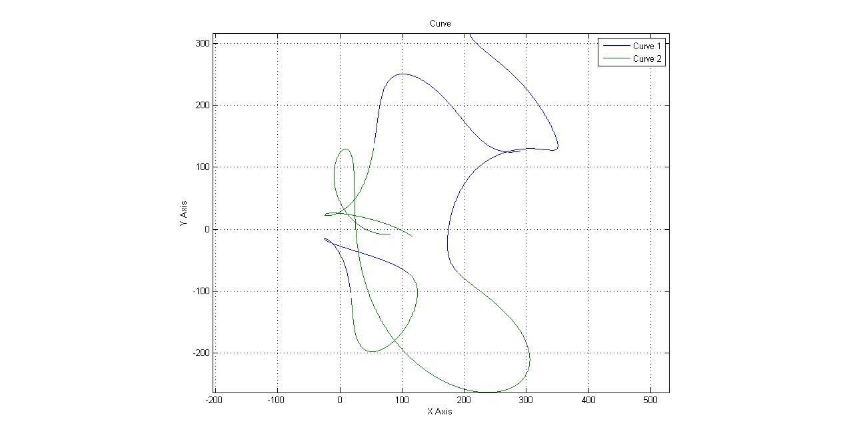

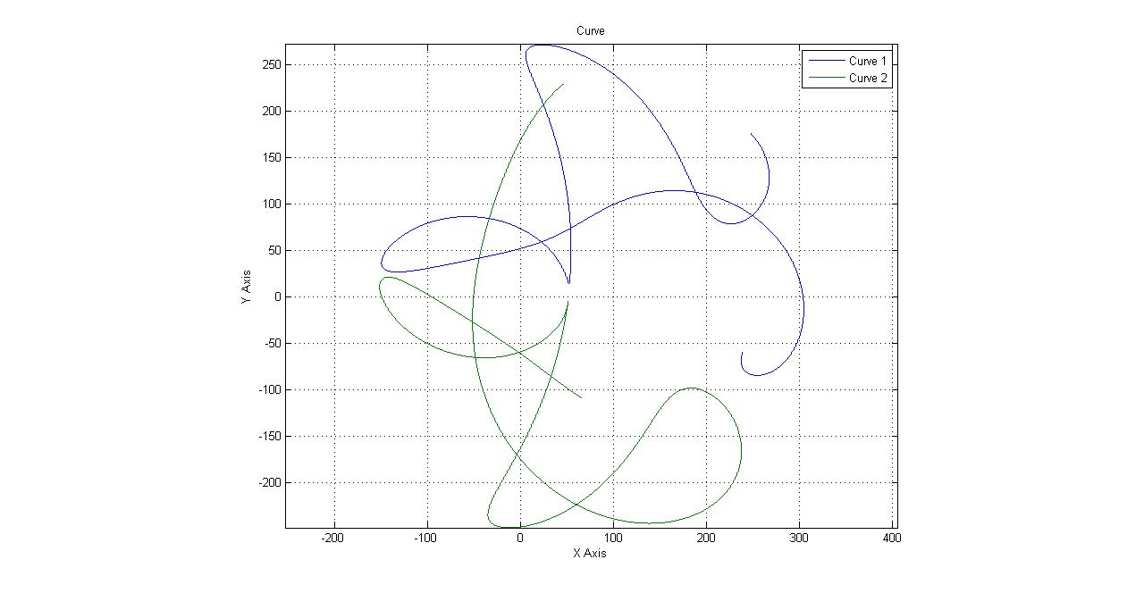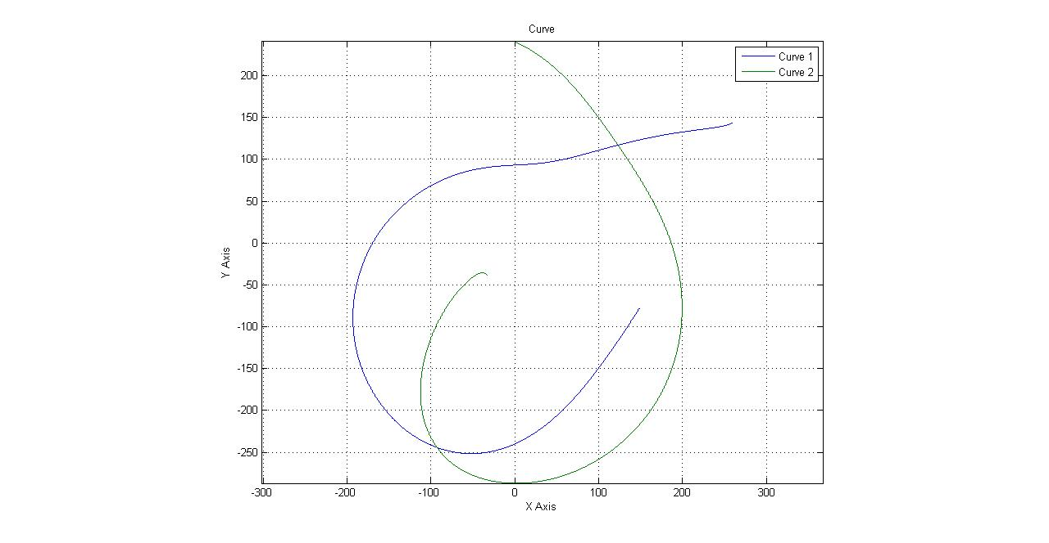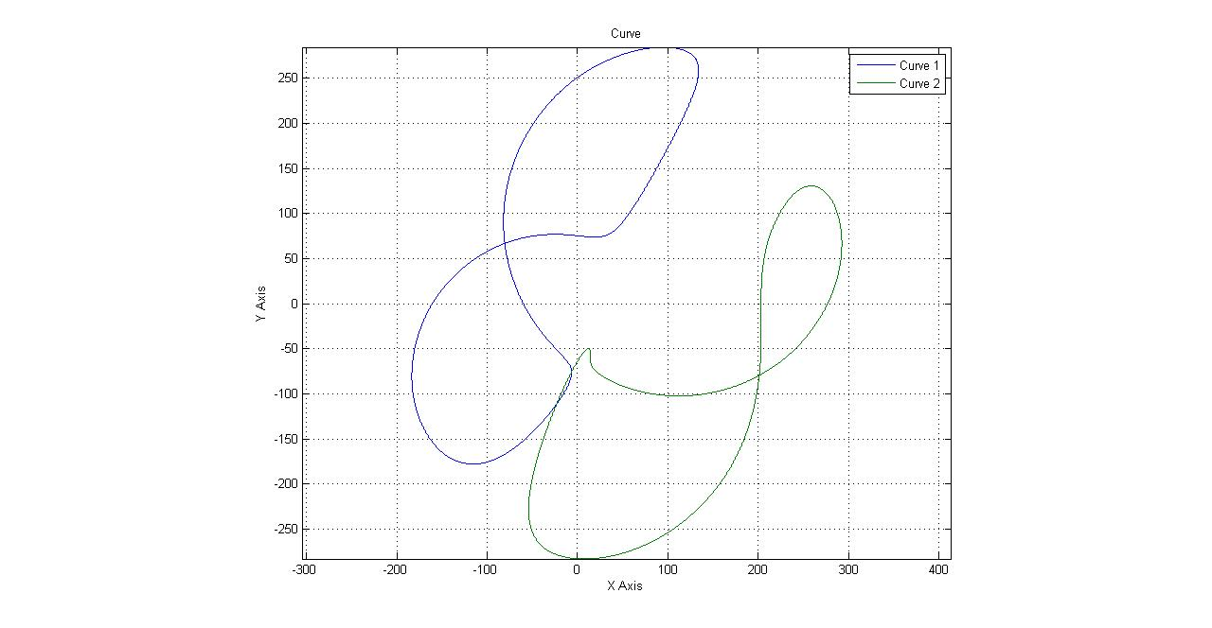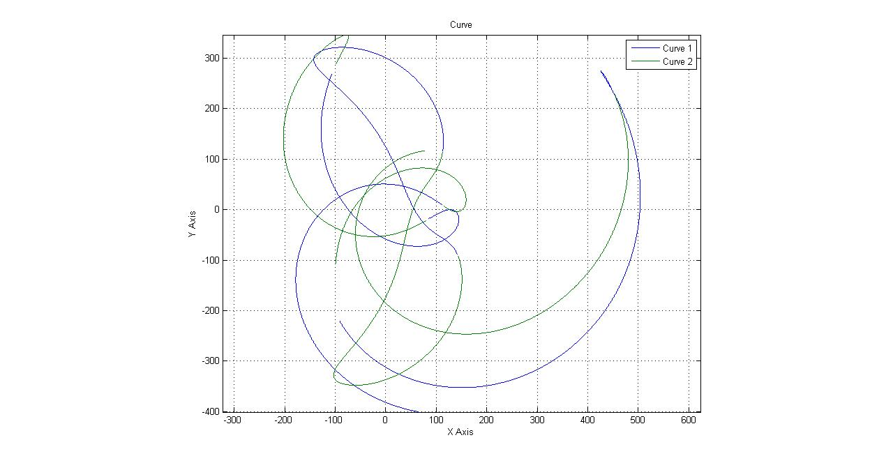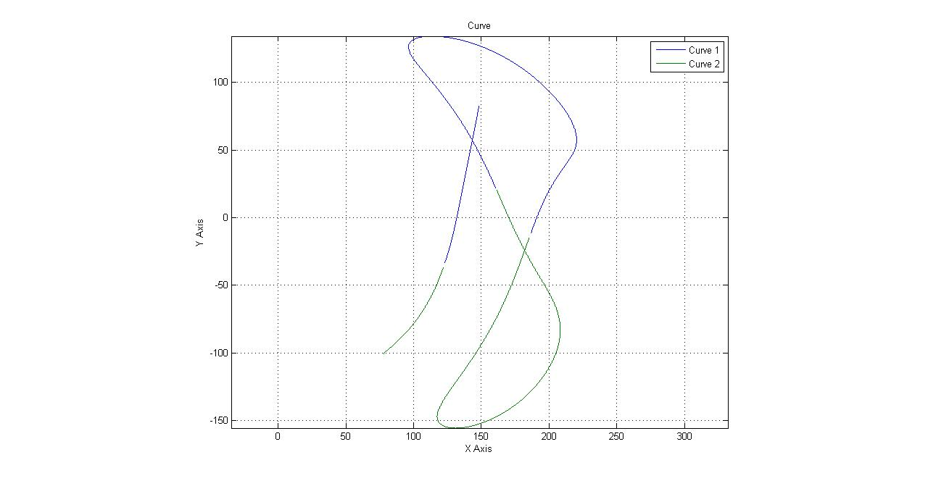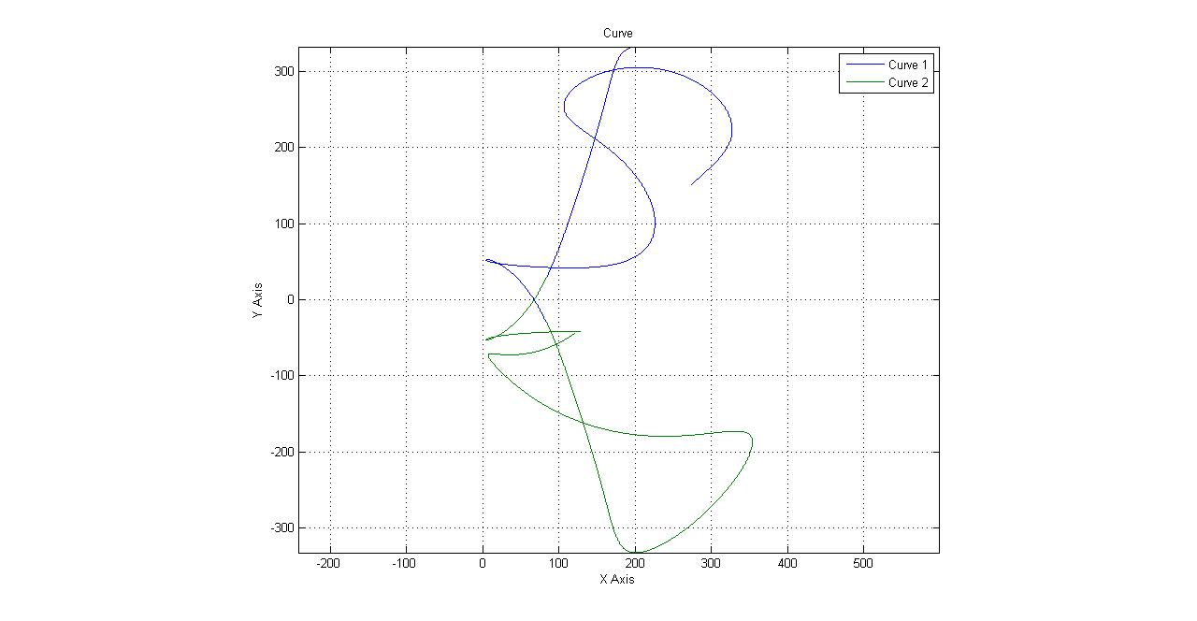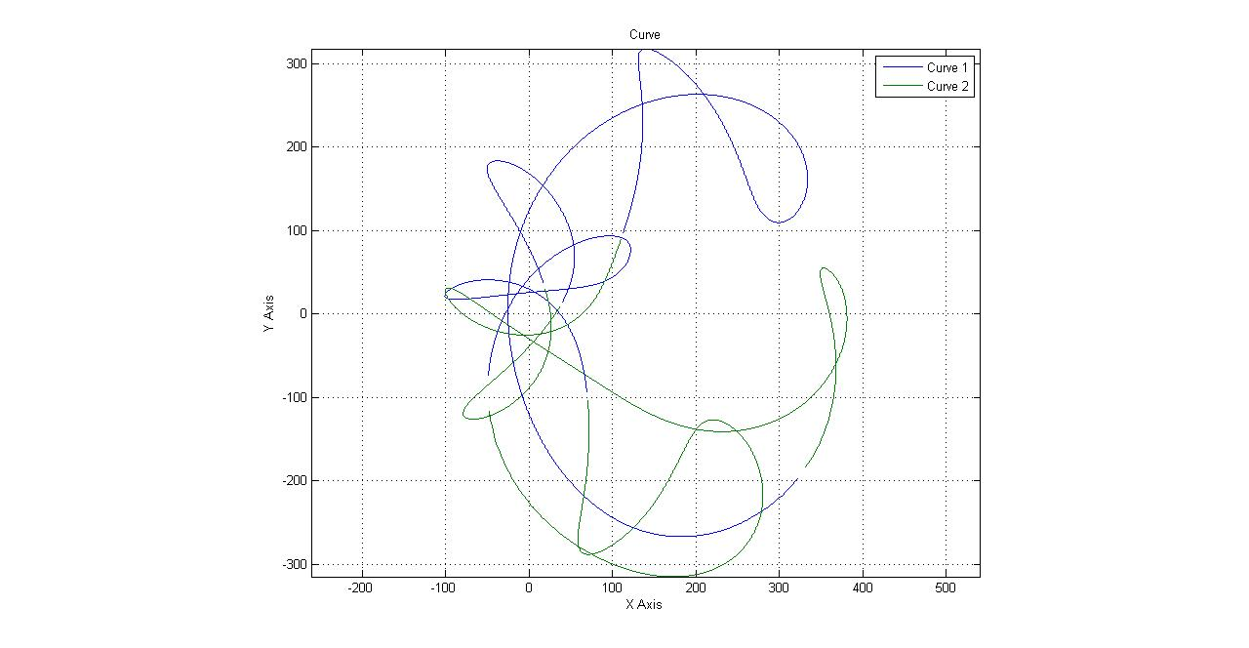

**Linkages (with Curves)**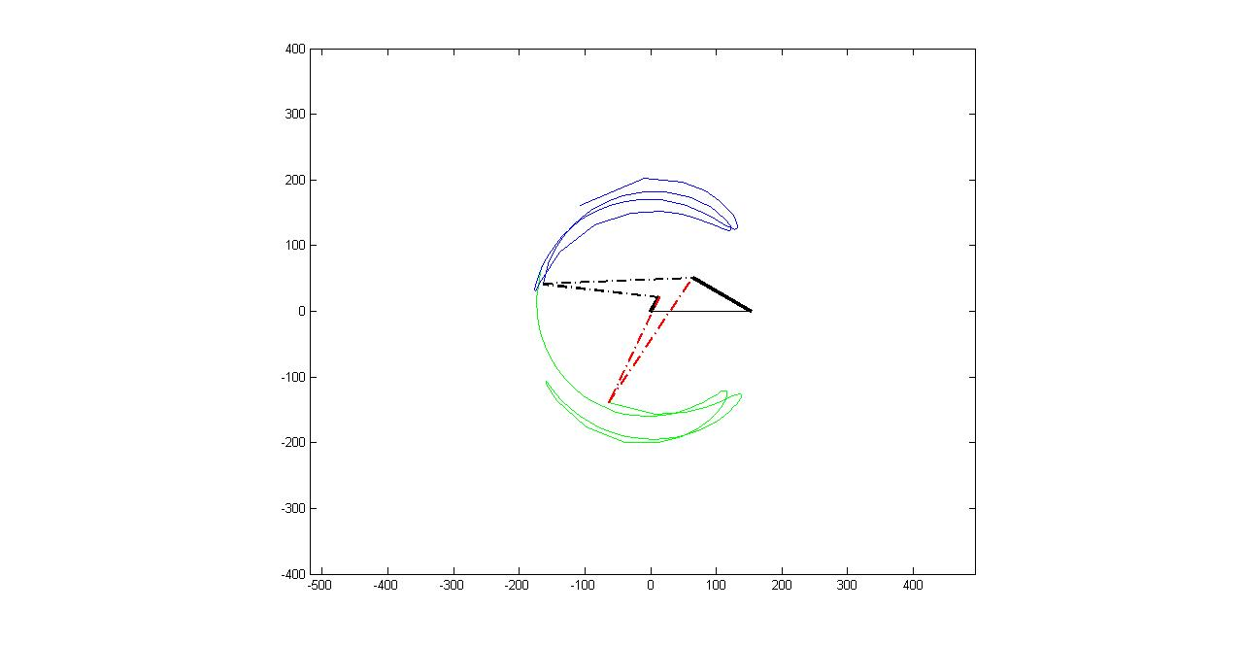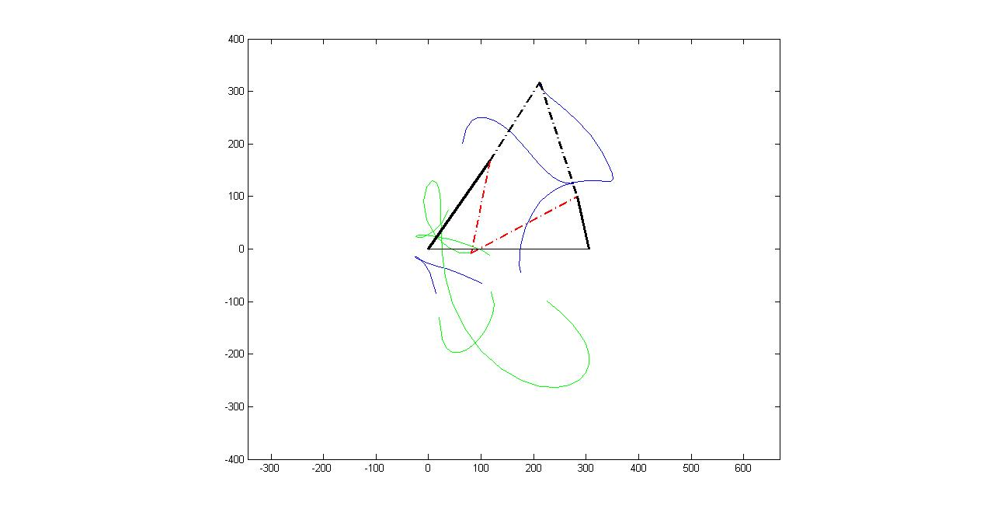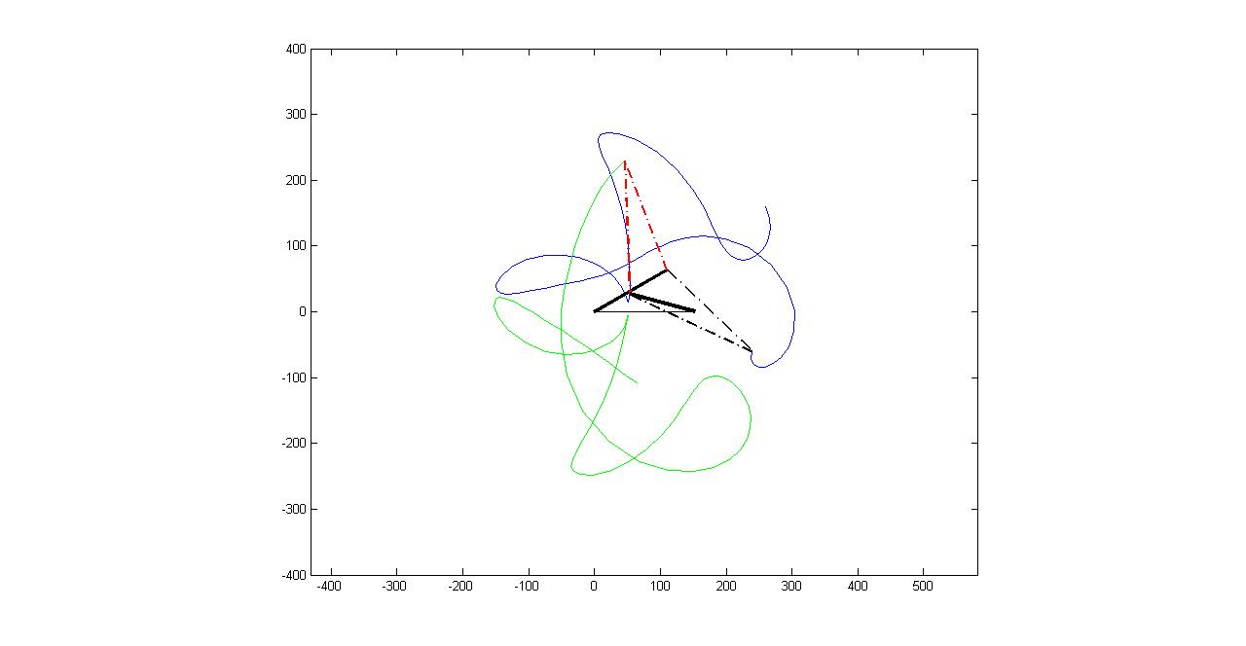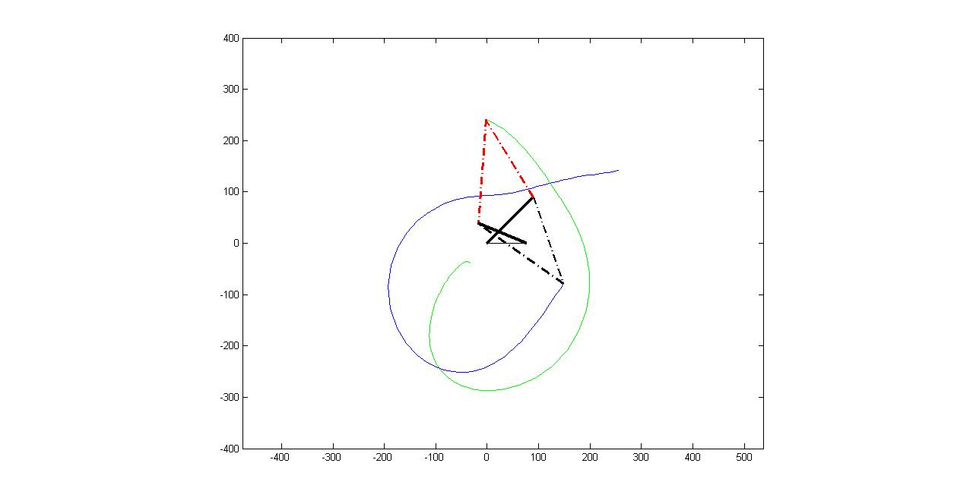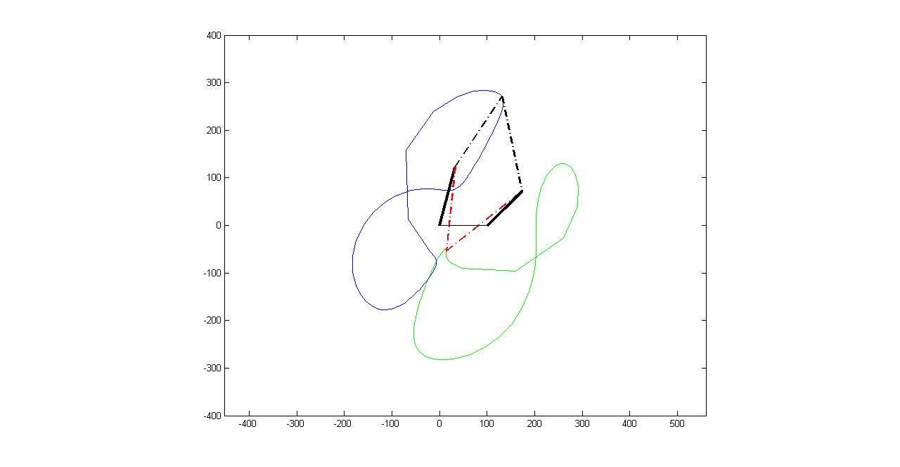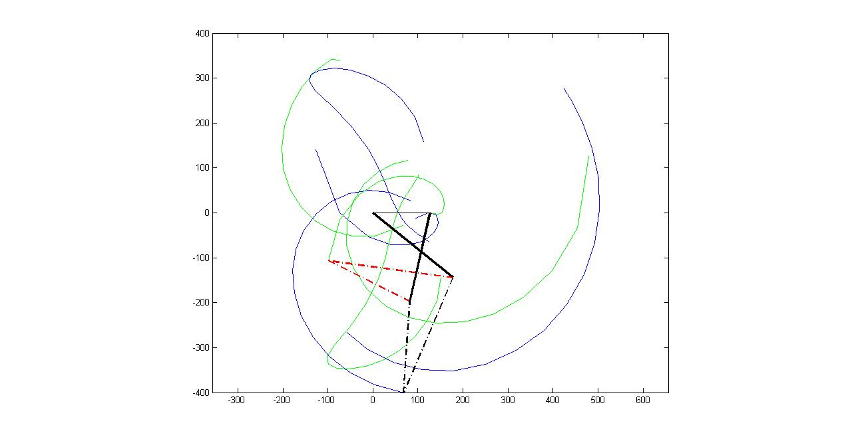

**MATLAB CODE**

The generated code is attached with the folder.

**program.m**: gives the solution to the angular velocities and accelerations.

**allcurve.m**: gives the locus curve of the point B.

**cometcurve.m**: gives the locus animation of the point B.

**Animation.m**: gives the animations of the linkage motion.

**References**

1. Matlab 2010b.

2. ‘Kinematics and Dynamic of Machinery’ RL Norton.